(Approx. 1,432 words)

External Storage
By Dick Maybach, member, Brookdale Computer Users’ Group, NJ
March 2013 issue, BUG Bytes
www.bcug.com
n2nd (at) charter.net

Although we use external storage much less than in the early days of home computing, it is still an essential technology for backing up internal hard disks, exchanging files among different computers, and expanding storage capacity. The increasing size of files had made obsolete many older technologies, and those that are still attractive fall into four types: electronic, optical, magnetic, and Internet.

There are many variations of electronic storage, but two are now dominant, USB memory sticks and SD cards. They have similar capacities with current “sweet spots” (capacities where the cost per byte is lowest) of around 16 Gbytes, although this is continually moving up. SD cards are typically faster, but appear to be less rugged with exposed connections and thinner packages. I have carried a naked USB memory stick in my key case for many years, and it has never failed, but I always keep my SD cards in their plastic cases. USB sticks have the further advantage that every computer has USB connectors, while SD access is less common, and although memory card readers available are very cheap, they also have low quality and often are unreliable. The circuits used for electronic storage do have finite lifetimes, in that they wear out after a (very large) number of writes; however, the risk is negligible for external storage devices.

Optical storage is problematic, because much the available media is of poor quality and may begin to develop errors in just a few months. Even high-quality media rapidly deteriorate if exposed to high heat or humidity. For more on this, see my article, Using DVDs for Long Term Storage, BCUG Bytes, June 2008, available at http://www.bcug.com. Actually, my own experience with CD-ROMs and DVDs has been good, although I'm careful to use only quality media. Of the dozens stored at home, some for several years, I've had problems with only one, which can be read only on the drive that created it. On the other hand, the outer tracks of several music CDs stored in my car are no longer playable. Another problem is the low quality of CD-ROM and DVD drives, with Blu-Ray being especially bad. Blu-Ray drives are acceptable for play-back, but their lasers frequently burn out after writing just a few discs. This is unfortunate, as the capacities of CD-Roms and DVDs are rapidly becoming too low to be really useful.

If you use optical storage for archiving, consider using the free program dvdisaster (http://dvdisaster.net/en/) for Linux, OS-X, and Windows, which adds error-correction and thus allows you to recover your stored files, even though up to 20 percent of the bits on the medium are corrupted. You need a disk-burning program that can create a file (called an iso-image) that is a bit-for-bit image of a CD-ROM or DVD and also has the ability to copy an iso-image to an optical medium. The procedure for creating an error-resistant disk is the follows.
- Use your disk burner to create an iso-image, which must be at least 20 per cent smaller than the capacity of the medium.
- Use dvdisaster to add error-correcting data to the iso-image. The screen-shot below shows this in progress. After creating this image, click on the Verify button to check that it's good.
- Finally, use your disk burner to write the iso-image to the optical medium.
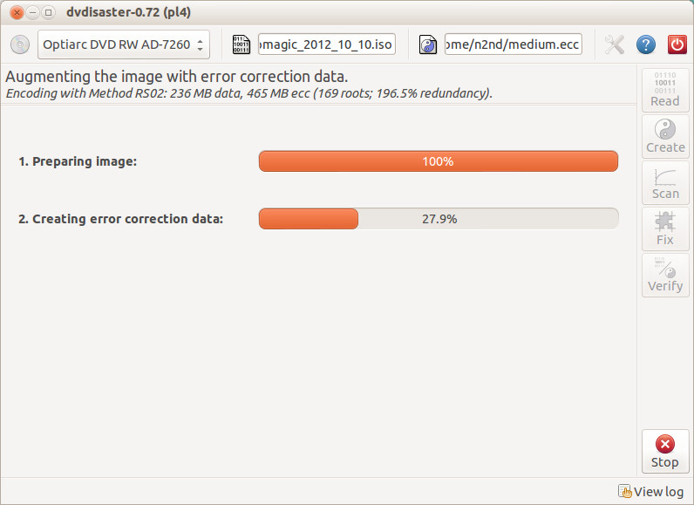
(Note the small blue circle containing a question mark at the upper left of the screen-shot. Clicking on it brings up an extensive manual in your Web browser, which you should read carefully.) Periodically scan your optical media (using dvdisaster's Scan button) for errors. If they begin to appear, recover the data using dvdisaster (which will produce an iso-image), create a new disk, and discard the one with the error. Until the medium begins to develop errors, you can read it like any other disk using your usual software.

Magnetic storage, in the form of external hard disks, offers high transfer speed and high capacity, making it attractive for many applications. It is also has the lowest cost per byte. To achieve this performance, these devices are assembled with very tight clearances, which means they must be sealed against air-borne contamination. The magnetic disks cannot be separate from the motor and head assemblies, making these devices much larger and less rugged than electronic storage devices. Here, you have a choice of interfaces with USB being the most common, followed by E-SATA. USB-3 drives are beginning to appear, but are considerably more expensive than USB-2, although this will surely change, probably soon. Diskettes are now obsolete, for good reasons. Their capacities are tiny, and their reliability is low. You can still buy drives, but their quality is very poor, with many delivered dead-on-arrival or failing very quickly. If you still have valuable data on diskettes, you should transfer it to a better medium soon.

Internet storage, commonly called “the cloud” is expanding rapidly. Modest capacities, up to around five Gigabytes, are widely available without charge. Transfer rates can be low, often just a few tens of kilobytes per second, and of course, the storage is available only if you have an Internet connection. There are also concerns about how secure the data is and whether it will continue to be available if the vendor goes out of business.

Which of these approaches you use depends on your application. For synchronizing the data among your own computers, Internet storage is the most convenient. Once you have set it up, the contents of the synchronized directories are always identical, no matter which computer you use to make changes. Since the information resides on every PC, you lose nothing if the cloud vendor discontinues the service.

For transferring files between your PC and a friend's, a USB memory stick (up to a few Gbytes) or a USB hard disk (for larger transfers) is the best choice. Almost every computer has a USB port, so your friend doesn’t need to install any special software or hardware to affect the transfer. I always carry an eight-Gbyte USB memory stick, formatted as FAT-32, in my key-case, and I've never found a computer that couldn't read from and write to it. (Actually, my stick has two partitions, a seven-Gbyte FAT-32 one for transferring files, and a one-Gbyte Linux one containing Parted Magic. See my article Parted Magic: Lots of Disaster-coping Tools, BCUG Bytes, April 2012, available at http://www.bcug.com. This means I always have the ability to transfer files and a tool kit to solve computer problems.)

For backing up your PC, and external hard disk is the only reasonable solution. These feature high capacities, fast transfer rates (especially if equipped with a USB-3 interface), and high reliability. Their bulk and relative high fragility are not serious problems in this application.

External hard disks are also good for archiving things like photos and financial data, but you could use DVDs, provided you add error-correction using and store them in a benign environment. For added security, consider making more than one copy, and either transfer the information to new media every few years or periodically scan it for errors using dvdisaster. Archival storage is an especially difficult problem. Computer technology is changing fast, and you must stay alert lest you lose the ability to access your archives (as happened to me when 5 ¼ inch diskette drives disappeared from PCs). For example, if you used dvdisaster to safeguard your archived DVD, you must be sure not only that the program runs on your new PC, but also that it uses the same methods as those used to record the data, and of course the new PC must be able to read DVDs.

For sharing photos or files with friends, Internet storage is hard to beat, although mailing them a DVD or CD-ROM also works well, especially if they want to show the pictures to their friends.

To expand internal disk storage capacity, the preferred solution is an external hard disk with an E-SATA interface, although USB-3 is not a bad solution. Most likely, you would use E-SATA for a desktop, since it requires an expansion card, and USB-3 on a laptop (USB-2 if your laptop is older or not top-of-the-line). Mac owners could consider Firewire or Thunderbolt.

As you can see, there is no single solution, unlike in ancient times when diskettes were universal (or if we go back to near pre-history, cassette tapes, audio tapes, punched paper tape, or even punched cards). However, there is a good and inexpensive solution for every application.

